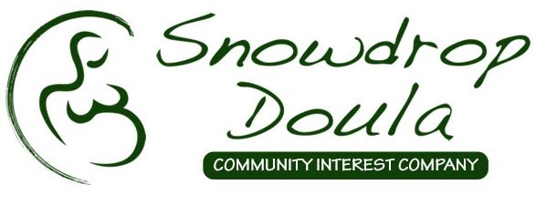

Code of Conduct
Staff and volunteers within Snowdrop Doula Community Interest Company agree to the following:
- Each parent is an individual with individual needs.
- Each birth and parenting choice is respected as the best for that family at that time.
- We believe that birth is a normal physiological process and an important journey in a mother and father’s life.
- Doulas are available for emotional and practical support but are not medically trained and are aware of the law regarding this. Doulas will provide information to enable informed choices.
- If a member of staff is uncomfortable in supporting a particular family then management should be made aware and more suitable support found. Or other appropriate signposting should take place.
- Mother’s wishes are respected at all times and confidentiality is paramount. (see Confidentiality Policy)
- Being aware of body autonomy of the woman and differing parenting choices we also acknowledge our legal duties to Safeguarding of children. Staff must attend training and have DBS checks where appropriate. (see Safeguarding Policy)
- Staff should strive to remain respectful to other staff and birthworkers at all times. (see Complaints procedure/policy)
- Staff will remain up to date on current research into birth and parenting related issues by continuous professional development throughout each year.
- All staff adhere to all policies and procedures within Snowdrop Doula Community Interest Company.
- Staff debriefing and reflection should take place regularly. This should be done appropriately.

